**Project 1: Implement azure active directory (azure ad) authentication**

Objective: implementing azure active directory (azure ad) authentication for a web application

Step-By-Step:

- https://learn.microsoft.com/en-us/azure/active-directory/develop/

- https://learn.microsoft.com/en-us/aspnet/core/security/authentication/azure-active-directory/

**1.Create an azure active directory (azure ad) tenant.**

**2.Create ASP.NET MVC Application**

MVC stands for Model–View–Controller — it's a software architectural pattern used to build web applications in a structured and maintainable way.

Model – The data layer

View – The UI layer

Controller – The logic layer

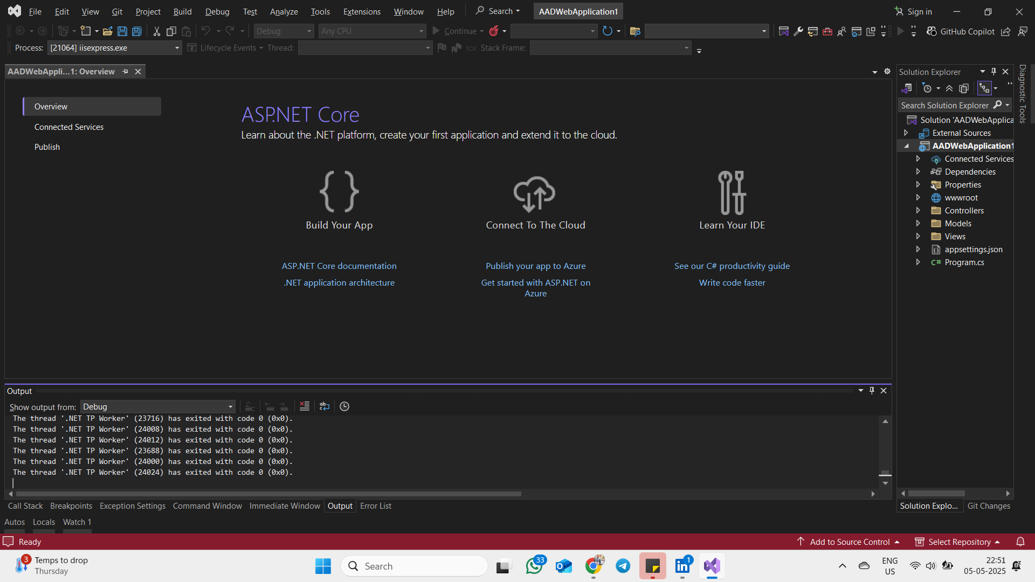

**3.Register an application in azure ad**

Azure App Registration is the process of registering your application in Azure Active Directory (Azure AD) so it can:

Authenticate users (sign in), Access Microsoft APIs (like Microsoft Graph), Be secured with tokens (OAuth 2.0 / OpenID Connect)

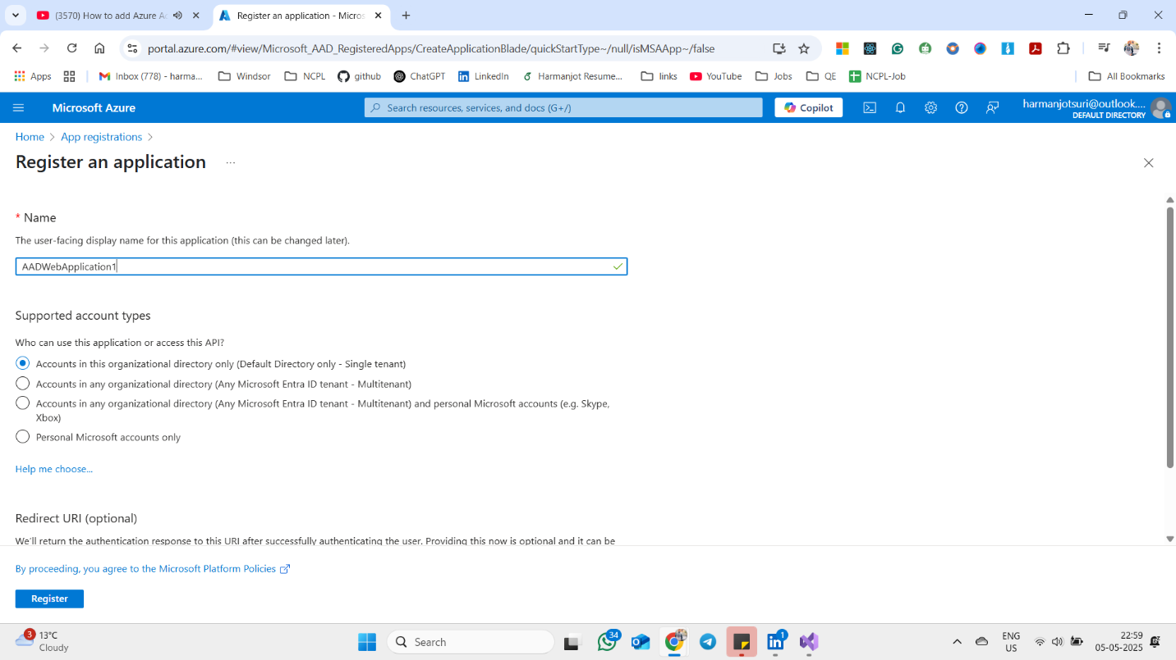

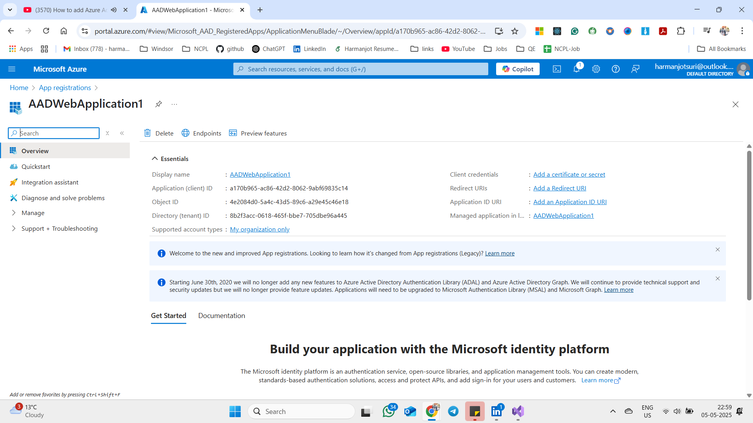

**4. Configure authentication and authorization settings for the application**

Download dependencies Nuget package- Microsoft Identity Web and Microsoft Identity Web UI

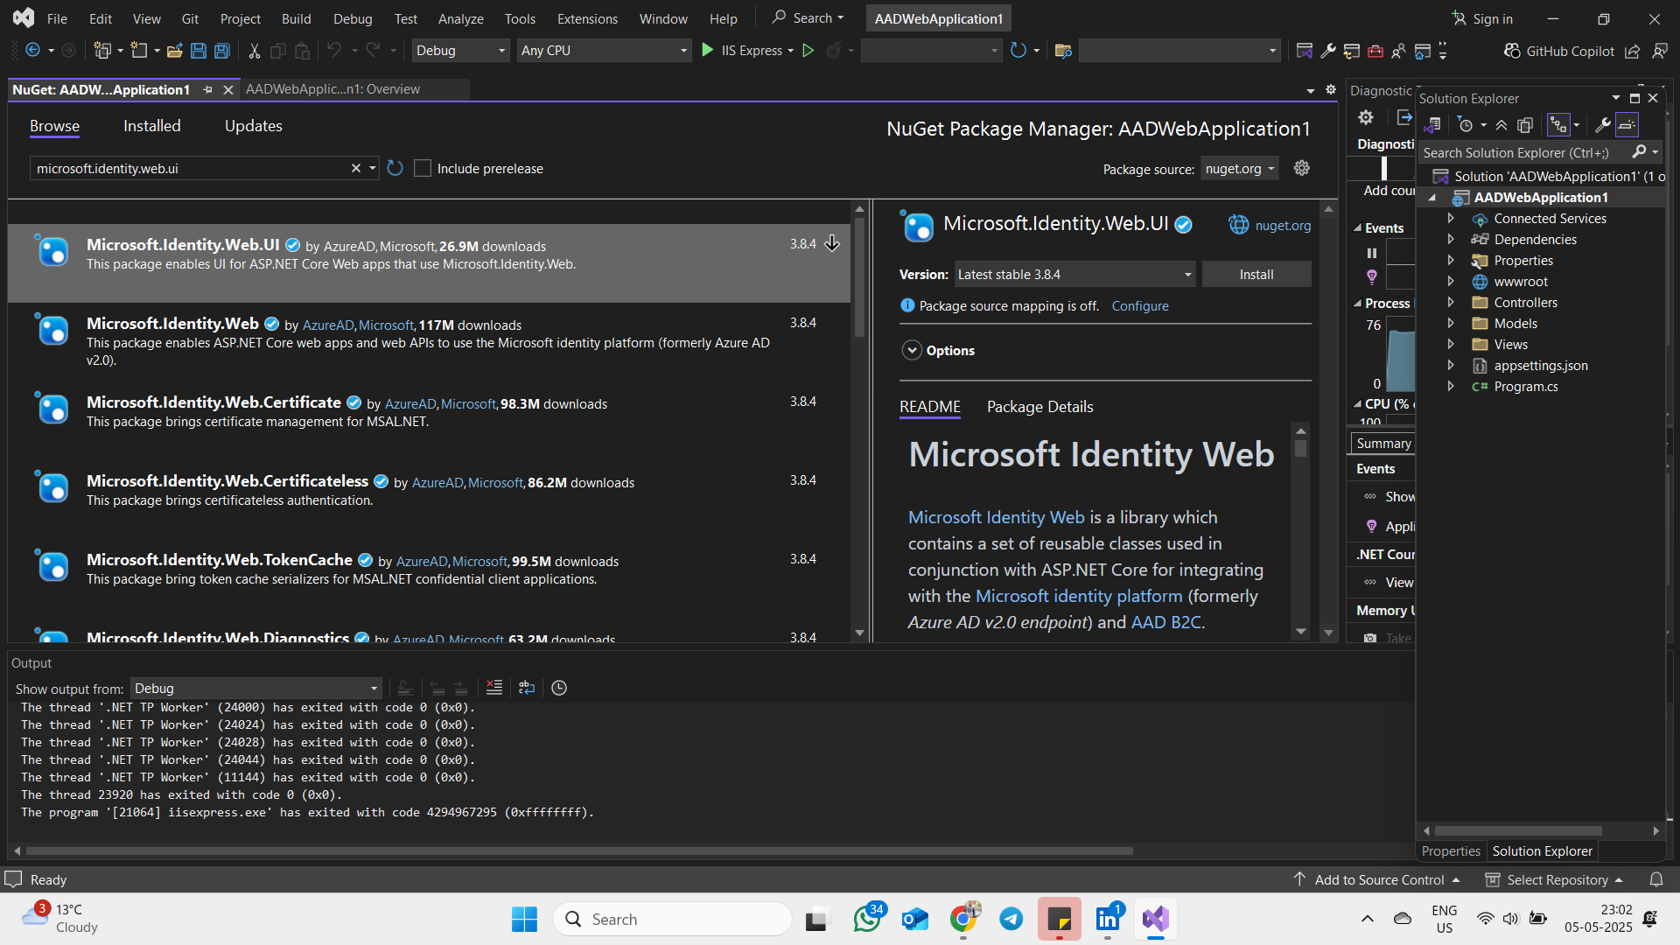

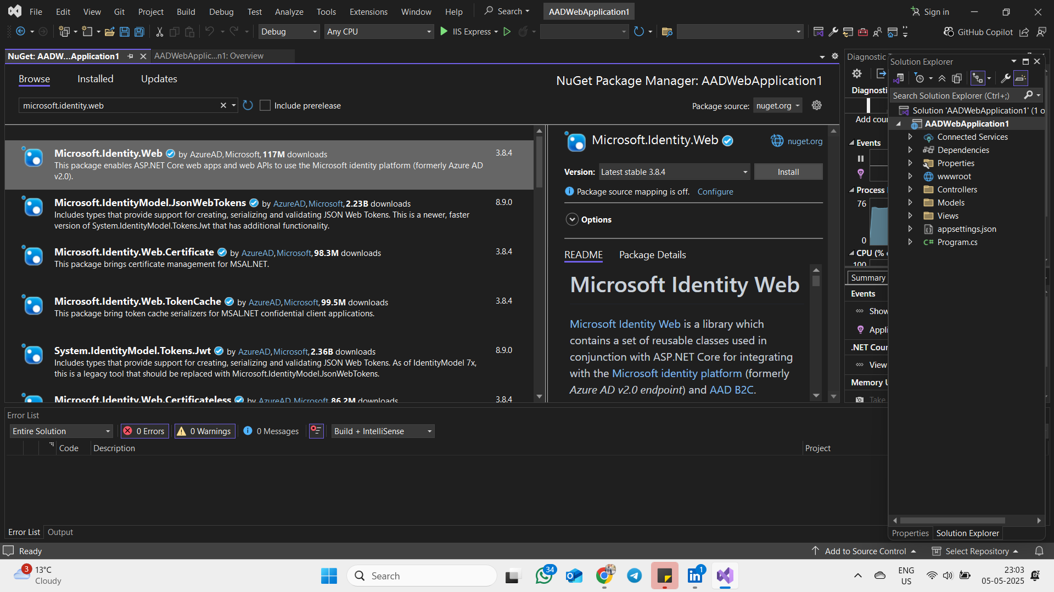

Add Scaffolded Items, Add Identity: Login and Logout

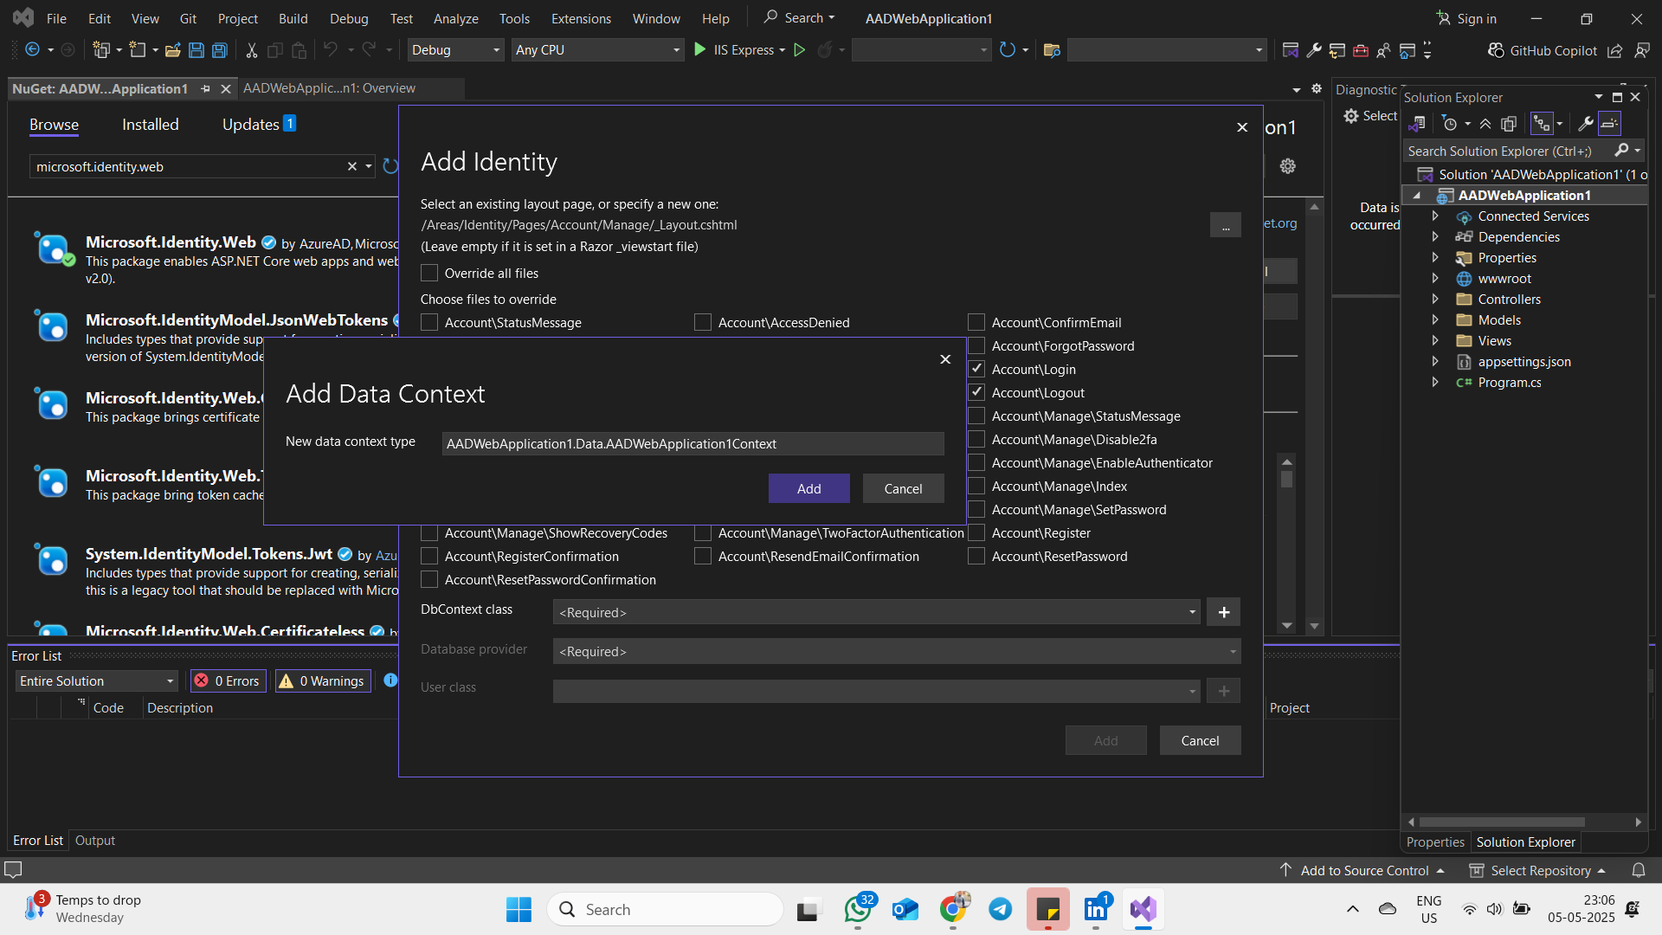

**5. Implement Azure AD authentication in a web application.**  
(Add AzureAD in appsettings.json to configure Azure App Registeration)

Modify startup.cs and program.cs

Program.cs sets things up and calls methods in Startup.cs.

Startup.cs configures what the app can do and how it should respond to requests.

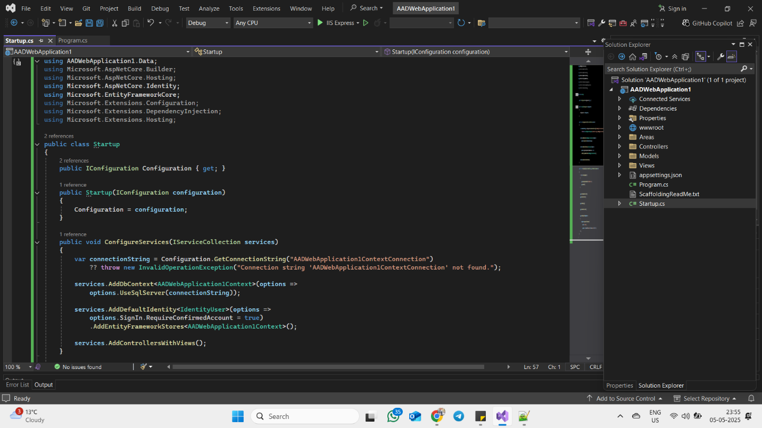

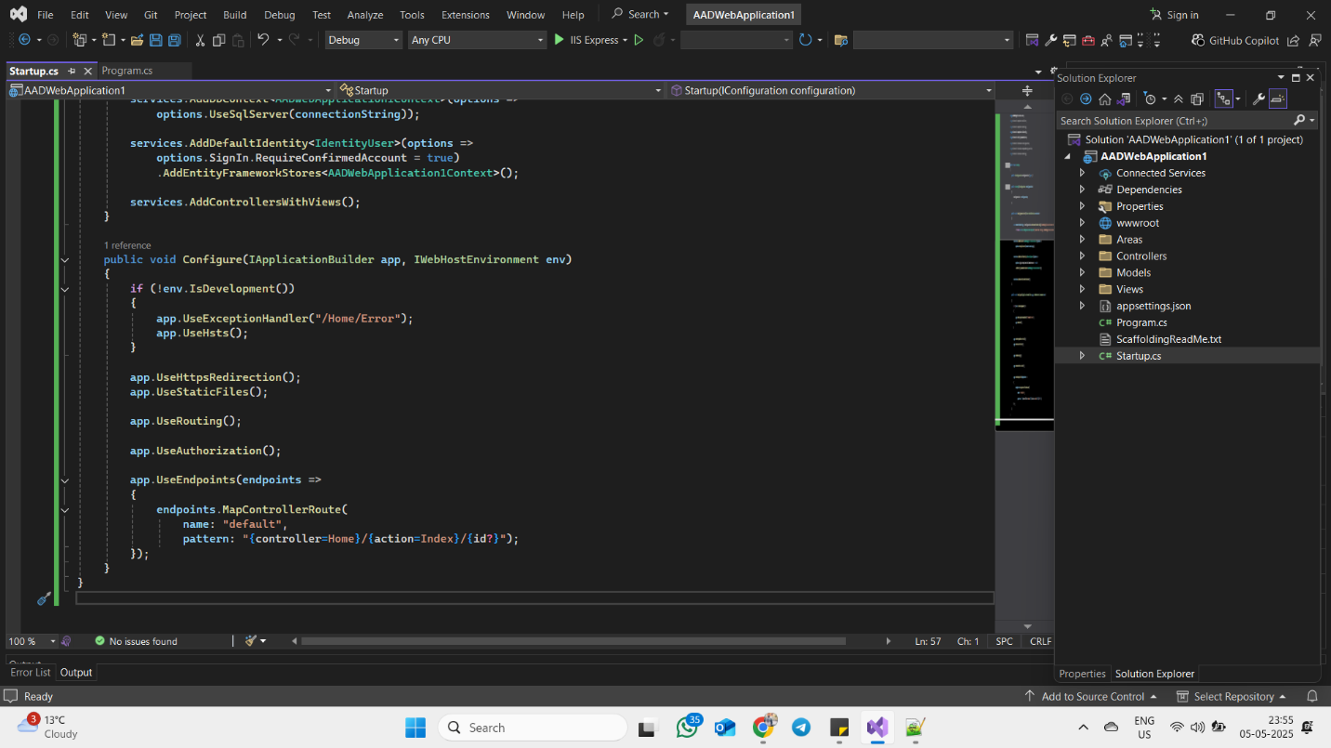

Open Azure app registration, authentication and add redirect url , front-channel logout url.

**6.Test authentication flow and access control using Azure AD users and groups.**

**Deliverables:**

azure ad tenant configuration.

registered application in azure ad.

authentication and authorization settings for the application.

web application with azure ad authentication implemented.

test results and any necessary troubleshooting documentation.

configuration for enabling sso (if applicable)